



October 2026
Hexaware Response -EPG - Two Labs RFP

- Content Area Content Area Content Area Content Area Content Area Content Area Content Area
- Content Area Content Area Content Area Content Area Content Area Content Area Content Area
- Content Area Content Area Content Area Content Area Content Area Content Area Content Area
- Content Area Content Area Content Area Content Area Content Area Content Area Content Area
- Content Area Content Area Content Area Content Area Content Area Content Area Content Area
Grow Digital >>

Shrink IT <<

VERTICALS
Table of Contents
1 Executive proposal summary <Saurabh/Anthony> 4
2 Understanding of the business problem <Sanjay> 6
3 Requirements compliance <Sanjay/Kundan/Hari/Praveen & Ram> 10
4 Proposed solution and architectural rationale <Kundan> 11
4.1 Solution overview 11
4.2 Technology choices and rationale 15
4.3 Reuse 16
4.4 Rules, reference data and change 16
4.4.1 Rule Representation 17
4.4.2 Effective-Dated Rule Management 17
4.4.3 Governance and Change Control 17
4.4.4 Testing and Regression Management 17
4.4.5 Transparency, Overrides and Auditability 17
4.5 Trade-offs and proportionality 22
4.5.1 Architectural Trade-Off Analysis 22
4.5.2 Complexity Deliberately Avoided 23
4.5.3 AI and Automation Strategy 24
4.5.4 Economic and Operational Benefits 25
5 Delivery methodology and implementation plan <Kundan/Vikrant/Hari/Praveen> 27
5.1 Methodology 27
5.2 Phases and milestones 27
5.3 Schedule 27
5.4 Dependencies and client participation 28
5.5 Testing and quality assurance 28
5.6 Implementation, training and transition 29
6 Proposed project team <Kundan, Santhosh, Hari,Praveen> 30
7 Security and non-functional compliance<Hari/Kundan/ Infra security team spoc,??> 31
8 Operating model and support approach <Santhosh/Kundan/Vikrant> 32
8.1 Steady-state operating activities 32
8.2 Support model 32
8.3 Maintenance, upgrades and releases 32
8.4 Business continuity 32
8.5 Exit and transition 32
9 Cost-efficiency and total-cost-of-ownership analysis < Kundan /Saurabh> 33
10 Commercial proposal <Saurabh/Anthony> 34
11 Assumptions, dependencies and exclusions<<Kundan, Santhosh, Hari,Praveen> 35
12 Relevant experience and references <Manick> 36
13 Risks and proposed mitigations <Kundan, Santhosh, Hari,Praveen> 37
14 Questions requiring clarification<Kundan, Santhosh, Hari,Praveen> 38
Declaration <Saurabh/Anthony> 39

Executive proposal summary <Saurabh/Anthony>
Hexaware proposes a unified, cloud-based Regulatory Operations Platform that modernizes Two Labs’ State Licensing and Drug Price Transparency services while preserving the regulatory expertise and historical information that underpin current operations. The solution consolidates fragmented applications, spreadsheets, documents, and task tracking into a secure multi-tenant platform supporting managed-service, hybrid, and self-service delivery models.
The platform combines shared services, configurable workflows, effective-dated regulatory rules, document and form generation, client collaboration, audit trails, reporting, and secure data management. State Licensing capabilities will support determination, intake, application preparation, deficiency management, issuance tracking, and renewals across all US states. DPT capabilities will evaluate launches and price changes against state-specific requirements, calculate reporting obligations and due dates, generate state-ready outputs, and maintain evidence of submission.
This approach directly addresses Two Labs’ need to scale compliance services without proportionate growth in manual effort. Regulatory logic and reference data are externalized from application code so authorized business and regulatory users can maintain rules through governed review, testing, approval, and publication processes. Effective dating preserves historical outcomes, while deterministic calculations, version control, explainability, and human oversight provide the auditability required for compliance-critical decisions.
The proposed architecture is intentionally pragmatic. A modular domain-based design, shared multi-tenant foundation, API-first integration model, and configurable rules framework reduce delivery complexity and recurring cost while retaining flexibility for future compliance services and SaaS growth. AI is not required for core compliance decisions; any optional AI-enabled capability will remain assistive, controlled, and subject to human review.
Pricing
One-time implementation price: ________________________________________________
Annual run cost: _____________________________________________________________
Total cost of ownership over the evaluation period: ________________________________
Pricing will be completed in alignment with the commercial workbook and agreed scope.
Proposed Schedule and Milestones
Overall duration: ______________________________________________________________
Proposed start date: ___________________________________________________________
Target go-live date: ____________________________________________________________
Key phases and milestones:
________________________________________________________________________________
________________________________________________________________________________
________________________________________________________________________________
Key Trade-offs
Trade-off | Decision | Benefit | Accepted Constraint / Control
Development efficiency vs. architectural flexibility | Use a modular domain-based platform rather than a highly distributed microservices landscape. | Faster implementation, simpler testing, and reduced integration and support effort. | Independent scaling is applied only where justified; clear domain boundaries preserve future decomposition options.
Cost to serve vs. physical tenant isolation | Use a shared multi-tenant platform with strong logical isolation rather than a dedicated database for every client. | Lower infrastructure, deployment, upgrade, and operational costs as the client base grows. | Tenant isolation is enforced through row-level security, encryption, access controls, monitoring, and security testing.
Automation vs. compliance oversight | Automate deterministic calculations, workflow, document generation, and alerts while retaining human approval for exceptions, overrides, and regulatory interpretation. | Reduces manual effort and turnaround time without making opaque technology responsible for compliance decisions. | Selected activities retain analyst or SME involvement, supported by governed approvals and complete audit trails.

Understanding of the business problem <Sanjay>
Describe in your own words:
the State Licensing and DPT services and their users;
the main problems with the current state;
the outcomes Two Labs is seeking;
what you see as the hardest parts of the problem and why.

State Licensing and DPT Services and Their Users
State Licensing (SL)
The State Licensing service helps pharmaceutical manufacturers determine which state licenses are required, collect supporting documentation, prepare and submit license applications, manage deficiencies, track approvals, and handle renewals throughout the license lifecycle.
Typical users include:
- Two Labs compliance analysts
- Regulatory subject matter experts

Account managers
- Client regulatory and compliance teams
- Client administrators responsible for licensing activities

Drug Price Transparency (DPT)
The DPT service helps pharmaceutical manufacturers identify state reporting obligations arising from drug launches, price increases, and product changes. The service evaluates state-specific reporting thresholds, generates required filings, maintains supporting evidence, and tracks reporting status.
Typical users include:
- Two Labs DPT analysts
- Regulatory SMEs
- Client pricing teams
- Market access and commercial operations teams
- Compliance stakeholders responsible for state reporting requirements

2. Main Problems with the Current State
The current operating model appears heavily dependent on manual processes, spreadsheets, and regulatory expertise embedded within individuals rather than within a technology platform.
Key challenges include:
- Regulatory rules, calculations, and interpretations are maintained across spreadsheets and SME knowledge.
- Significant analyst effort is required for determinations, report preparation, document collection, and compliance tracking.
- Regulatory changes require manual review and updates.
- Limited client self-service capability creates operational overhead.
- Historical decisions and calculations may not be consistently traceable.
- Knowledge concentration creates scaling and continuity risks.
- Growth in clients and regulatory complexity will likely require proportional growth in operations staff unless automation is introduced.

3. Outcomes Two Labs is Seeking
Two Labs appears to be pursuing a transformation from a people-intensive compliance service into a technology-enabled compliance platform.
Desired outcomes include:
- Standardized and automated compliance workflows.
- Reduced dependence on spreadsheets and manual reviews.
- Support for managed-service, hybrid, and self-service operating models.
- Improved client experience and transparency.
- Increased scalability without equivalent increases in headcount.
- Faster onboarding of clients and regulatory jurisdictions.
- Consistent and explainable compliance decisions.
- Comprehensive audit trails for determinations, calculations, approvals, overrides, and submissions.
- A reusable SaaS platform capable of supporting future compliance offerings.
Ultimately, the goal is to improve operational efficiency while maintaining regulatory accuracy and compliance confidence.

4. Hardest Parts of the Problem and Why
A. Regulatory Rule Capture and Governance
The most difficult challenge is converting years of accumulated regulatory knowledge into a structured and maintainable rules framework.
Many licensing decisions, thresholds, calculations, exceptions, and interpretations currently reside in:
- SME expertise
- Operational practices
- Spreadsheets
- Supporting documentation
The risk is not building the software; it is ensuring that automated decisions exactly replicate trusted business outcomes.

B. Regulatory Accuracy and Liability
Unlike most workflow applications, an incorrect outcome may directly result in regulatory exposure.
Examples include:
- Incorrect licensing determination
- Incorrect price-transparency calculation
- Missed filing deadline
- Incorrect state submission
Any of these could potentially result in client penalties, compliance findings, or reputational damage.
Therefore, every determination must be:
- Explainable
- Auditable
- Version-controlled
- Reproducible
- Testable
This makes the rules engine and governance framework more important than the underlying technology stack.

C. Managing Constant Regulatory Change
State licensing requirements and DPT regulations evolve continuously.
The platform must support:
- Effective-dated rules
- Historical calculations using rules that existed at the time
- Regulatory version management
- Controlled approval of rule changes
Without this capability, compliance risk increases significantly over time.
D. Balancing Automation and Human Oversight
Two Labs wants to increase automation and client self-service, but compliance activities often require human judgment.
The challenge is determining:
- What can be fully automated
- What requires analyst review
- What requires SME approval
- What can be exposed directly to clients
Over-automation increases compliance risk, while excessive manual review reduces scalability.
Overall Assessment
From a business perspective, this is a compliance services modernization initiative focused on scaling expertise, improving customer experience, and reducing operational effort.
From a technical perspective, this is primarily a regulatory decision-management platform, not simply a workflow or portal application. The greatest implementation risk is accurately translating regulatory knowledge, calculations, and interpretations into a governed, auditable, and maintainable rules framework while ensuring that compliance-critical outcomes remain accurate and defensible.

Requirements compliance <Sanjay/Kundan/Hari/Praveen & Ram>
Confirm that the Requirements Compliance Matrix is complete. Then summarise:

Measure | Count
Required requirements: Fully supported
Required requirements: Partially supported
Required requirements: Requires development
Required requirements: Not supported
Required requirements: Clarification required
Optional capability groups proposed (of 18)

List every Required requirement marked Partially supported or Not supported, with the gap and any proposed alternative.

Proposed solution and architectural rationale <Kundan>

Solution overview
Describe the solution, its major components and how users experience it. Include a diagram.
Hexaware proposes a unified cloud-based Regulatory Operations Platform supporting State Licensing (SL), Drug Price Transparency (DPT) and Regulatory Intelligence. The platform supports Managed Service, Hybrid and Self-Service operating models and provides a common foundation for workflow, security, content management, auditability and regulatory operations
Major Components:
- Shared Platform Services
- State Licensing Module
- Drug Price Transparency Module
- Regulatory Intelligence Services
- Business Rule Engine
User Experience:
Licensing Analysts and DPT Analysts operate through a common workbench with task queues, dashboards, reviews and approvals. Clients access a secure portal for intake, uploads, reviews, compliance tracking and regulatory updates. SMEs manage rules, reference content and regulatory interpretations.

Drug Price Transparency (DPT) Module - SaaS Architecture & Workflow
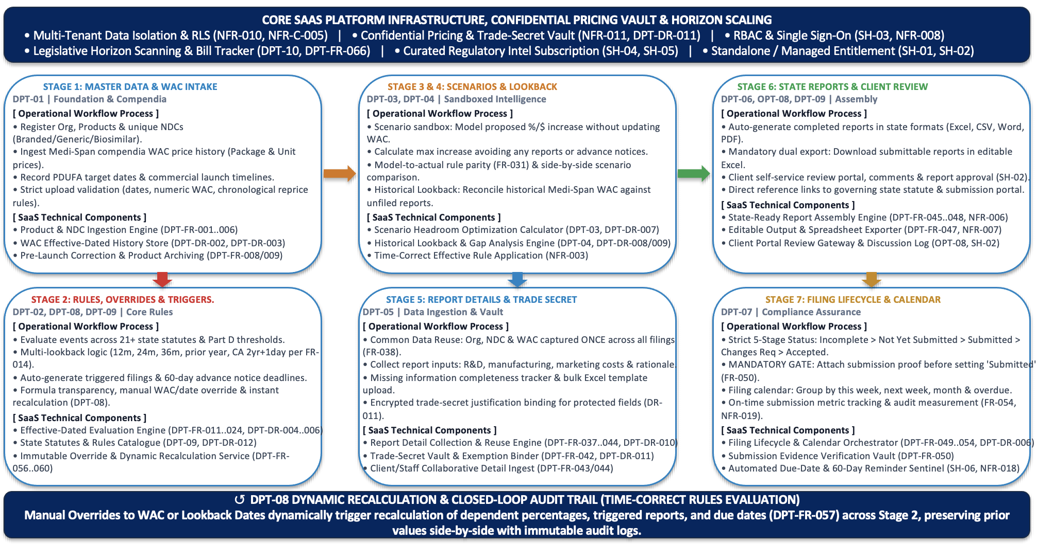
We will build the Drug Price Transparency (DPT) Engine as a secure, multi-tenant cloud platform to automate, evaluate, and track statutory drug pricing reporting across 21 US states (and future expanding jurisdictions). Designed to eliminate the severe financial exposure of daily non-compliance penalties, our platform will replace manual spreadsheets and repetitive data entry with a deterministic, effective-dated rules engine.
We will deliver a unified platform that simultaneously supports three operating tiers:
• Two Labs Managed Services: Internal analyst workbenches with centralized queues and task dispatchers.
• Hybrid Client Collaboration: Shared workspaces for collaborative data review, commenting, and sign-offs.
• Standalone Client Subscriptions: A client-operated SaaS model featuring self-service headroom modeling and automated report generation.
2. End-to-End Architectural Pipeline We Will Build
• 1. Master Pricing & Product Intake: We will implement an automated ingestion engine that validates multi-product catalogs, classification hierarchies (Brand, Generic, Biosimilar), and unique 11-digit NDCs. We will establish an effective-dated package and unit Wholesale Acquisition Cost (WAC) price history ledger with chronological validation to eliminate sequencing errors.
• 2. Effective-Dated Rules Engine: We will engineer a temporal rules engine that evaluates commercial launches, reprices, line extensions, and target action dates against 21+ state statutes and dynamic Medicare Part D thresholds. The engine will calculate rolling lookback baselines (12, 24, and 36 months, prior calendar year, and California’s 2-year-and-a-day baseline) to trigger required filings and surface 60-day statutory advance-notice deadlines.
• 3. Closed-Loop Recalculation & Formula Transparency: We will provide complete mathematical transparency by rendering the exact statutory citation, baseline WAC, and lookback date applied to every result. We will build an override console where manual adjustments instantly trigger dynamic recalculation across all dependent filings while logging prior and revised values in an immutable audit ledger.
• 4. Sandboxed Intelligence (Headroom & Historical Audits): We will build a Headroom Optimization sandbox that models hypothetical price increases without modifying live records, solving for the maximum increase that avoids triggering filings. We will also build an onboarding reconciliation tool that ingests standardized compendia (Medi-Span) pricing and audits past pricing events against historical statutes to generate gap reports.
• 5. Single-Entry Data Normalization & Trade-Secret Vaulting: We will build a data fabric where common manufacturer, product, NDC, and price metrics are entered once and automatically populate all triggered state filings. We will implement an encrypted trade-secret vault to sequester sensitive cost disclosures (R&D, manufacturing, marketing) and legal justifications.
• 6. State-Ready Multi-Format Document Assembly: We will develop an automated document generator that compiles submittable reports directly into official state formats (Excel, CSV, Word, or PDF) without manual reformatting, alongside editable spreadsheet downloads and in-portal client review workflows.
• 7. Filing Lifecycle Governance & Verification Gate: We will establish an end-to-end lifecycle tracker with a mandatory proof-of-submission gate that prevents any report from being marked complete without an attached filing receipt. The system will provide interactive calendar views, automated deadline alerting, and on-time turnaround analytics.
3. Technical & Security Foundation We Will Implement
• Multi-Tenant Data Isolation: We will enforce database-level Row-Level Security (RLS) within Amazon Aurora PostgreSQL to guarantee strict logical data segregation across client organizations.
• Hardware-Backed Encryption: We will protect pre-launch pricing, proprietary cost breakdowns, and state portal credentials using AWS KMS envelope encryption at rest and TLS 1.3 in transit.
• Bi-Temporal Immutability: We will store all state rules and thresholds with explicit validity date ranges. When a state amends a statute, the update will apply forward-only, leaving past audits and historical calculations mathematically untouched.
• Legislative Horizon Scanning: We will ingest commercial bill feeds to track pending state legislation, feeding an internal workspace where legal analysts curate actionable advisories for subscribers.
4. Target Operational Commitments
• Zero Re-Keying: Common manufacturer, drug, and pricing data will flow automatically into every state report.
• Zero Lost Deadlines: Automated alerts will enforce proactive visibility across 60-day advance notices and post-increase deadlines.
• Audit-Defensible Accuracy: Every calculation will provide mathematical transparency, side-by-side override logs, and full statutory traceability.

State Licensing Module - Target SaaS Architecture & Operational Workflow
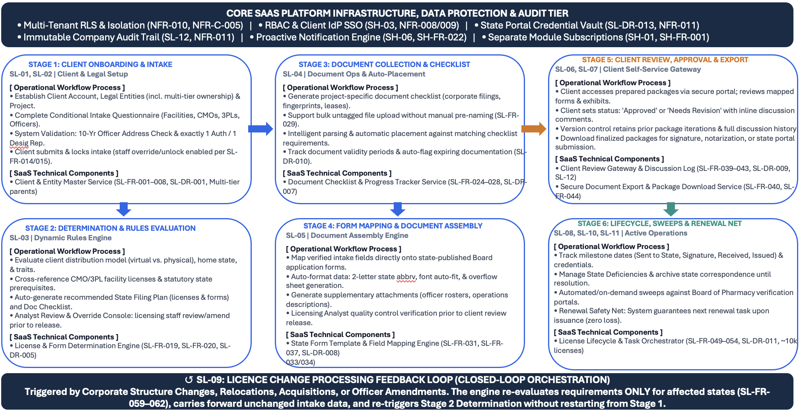
We will build the State Licensing (SL) Engine as a multi-tenant cloud platform to automate, govern, and track the full licensing lifecycle across all 50 US states. Managing regulatory compliance across facility permits, wholesale distribution licenses, virtual manufacturer authorizations, and 3PL certifications currently demands extensive manual coordination.
Our platform will replace disconnected spreadsheets, manual document matching, and generic CRM task boards with a centralized rules engine and automated document pipeline. We will deliver a unified solution supporting three operational models:
• Two Labs Managed Services: A high-throughput analyst workbench with centralized queues, automated task dispatching, and deficiency tracking across ~10,000 managed licenses.
• Hybrid Client Collaboration: A secure client portal for completing dynamic intake, uploading corporate records, and executing in-line application reviews and approvals.
• Standalone Client Subscriptions: A self-service licensing operating system providing automated requirement determination, renewal calendars, and live status dashboards.
2. End-to-End Architectural Pipeline We Will Build
• 1. Client Onboarding & Dynamic Conditional Intake: We will implement an onboarding engine supporting multi-tier corporate ownership hierarchies (parent, grandparent, and great-grandparent entities). The questionnaire will conditionally render operational sections (e.g., dedicated CMO and 3PL tabs) based on real-time client responses. The system will enforce strict validation gates: verifying 10 cumulative years of residential address history for all representatives and confirming exactly one Authorized Rep and one Designated Rep before locking the intake.
• 2. Dynamic Determination & Rules Matrix Engine: We will build a multi-dimensional determination matrix that evaluates manufacturer distribution models (virtual, physical, wholesale, 3PL), home-state jurisdictions, product types, and commercial activities. The engine will auto-determine required state licenses, application forms, and tailored document checklists, providing an analyst console for reviewing or overriding requirements prior to client publishing.
• 3. Document Ingestion, Auto-Placement & Expiry Sentinels: We will build a document management service supporting individual checklist uploads alongside a bulk, untagged dropzone. An ingestion pipeline will parse file metadata and text to automatically place documents against corresponding checklist items (Good Standing Certificates, leases, fingerprint cards). Background sentinels will monitor document validity dates to flag expiring records before state submissions occur.
• 4. State Form Mapping & Document Assembly Engine: We will engineer an automated document generation service that maps verified intake data directly into state-published Board of Pharmacy PDF and Word forms. The engine will format data to statutory standards (e.g., 2-letter state abbreviations, font auto-fit) and automatically generate supplementary addenda when input data overflows standard form fields. A monthly currency monitor will compare form hashes to detect newly published state agency templates.
• 5. Client Portal Review, Collaboration & Export Gateway: We will deliver a client-facing portal workspace where clients review prepared state application packages, post in-line revision comments, and set formal status sign-offs ('Approved' or 'Needs Revision'). Final approved packages will be compiled for secure download alongside signature and notarization instructions.
• 6. Filing Milestone Tracking & Deficiency Resolution: We will build an active filing lifecycle tracker that captures critical milestone dates (Sent to State, Sent for Client Signature, Received Back, Issued). A dedicated deficiency management vault will log state board notices, track cure deadlines, and preserve full correspondence histories. State portal login credentials will be secured in a hardware-backed vault for authorized renewal access.
• 7. Renewal Safety Net, Board Sweeps & Closed-Loop Change Engine: We will implement an automated Renewal Safety Net guaranteeing that every issued license automatically instantiates an active, tracked renewal task with calculated statutory due dates, eliminating lapsed licenses. Containerized web scrapers will sweep 50 State Board of Pharmacy portals to automate facility status verification. When a client undergoes corporate restructuring or officer changes, our change engine will re-evaluate delta requirements only for affected states without restarting intake.
3. Technical & Security Foundation We Will Implement
• Multi-Tenant Isolation: We will enforce database-level Row-Level Security (RLS) within Amazon Aurora to ensure mathematical data segregation between client tenants across all entities, documents, and licenses.
• Hardware-Backed Credential & PII Vaulting: We will protect officer Social Security Numbers, dates of birth, and state-system login passwords using AWS KMS envelope encryption (AES-256-GCM) at rest and TLS 1.3 in transit.
• Immutable Compliance Audit Ledger: Every modification to corporate legal structures, representative histories, and licensing milestones will be logged in a tamper-evident audit ledger with user attribution, timestamps, and side-by-side delta tracking.
• Proactive Notification Engine: Automated background workers will dispatch reminders for approaching renewal deadlines, expiring certificates of good standing, and semi-annual intake review prompts.
4. Target Operational Commitments
• Zero Dropped Renewals: Every issued license will automatically create a tracked renewal record upon issuance.
• Zero Re-Keying: Entity, facility, and officer data will be entered once and populate across all 50 state application forms and addendum.
• Automated Licensure Proof: Weekly scraping sweeps will verify active facility status directly against State Board of Pharmacy records.
• Accelerated Change Processing: Corporate amendments will evaluate delta requirements without forcing clients to repeat complete intake.

Reference Architecture – AWS

<TBD>

Technology choices and rationale
Component | Technology, product or service | Why chosen | Alternatives considered | Licensing model

Reuse
Describe existing products, platforms, components or parts of the existing internal applications you will reuse, and why.
Based on the information provided in the RFP, the existing State Licensing and DPT applications contain valuable business functionality and data but operate on separate technology stacks and require significant manual processes, spreadsheet support, and developer intervention for regulatory updates.
Our recommendation is to:
- Retain and migrate business data, rules, forms, templates, and historical records.
- Reuse business process knowledge and operational workflows.
- Modernize the application architecture through a consolidated platform.
- Avoid direct reuse of legacy application code unless technical due diligence identifies components that provide measurable value and can be economically incorporated into the target solution.
This approach allows Two Labs to preserve its regulatory intellectual property and historical data while eliminating technical constraints that would otherwise limit scalability, self-service adoption, and future SaaS commercialization.
Our recommendation is:
- Replace the legacy application codebases with a unified, modern web platform.
- Retire the external CRM task-tracking system and absorb licensing tasks directly into the platform (SL-08, OPT-06).
- Migrate and preserve all underlying business assets: client master data, intake questions, state filing plan matrices, state form mappings, ~10,000 historical license records, Medi-Span WAC histories, and the 21-state rule catalog.

Rules, reference data and change
Explain how State Licensing determination logic and DPT state rules will be represented, maintained, tested and changed over time, including how a rule change leaves results for earlier events unchanged.

The proposed solution adopts a metadata-driven architecture in which regulatory rules, determination logic, thresholds, forms, templates, and reference data are managed independently of application code. This approach enables Two Labs to respond rapidly to regulatory changes while maintaining full traceability, historical accuracy, and governance control.
By externalizing regulatory knowledge from the application layer, the platform minimizes dependency on software releases, supports business-led rule administration, and provides a sustainable foundation for future self-service and SaaS capabilities.

Rule Representation
State Licensing Determination Logic
State Licensing determination logic will be represented through configurable decision models and reference matrices maintained within a centralized rules repository.
The determination framework evaluates client-specific characteristics including distribution model, facility structure, home state, target jurisdictions, CMO relationships, 3PL relationships, and operational attributes.

Client Profile -> State Licensing Determination Engine -> Licenses | Forms | Documents | Filing Plan
Drug Price Transparency Rules

DPT requirements will be represented as configurable regulatory rules governing trigger conditions, thresholds, lookback calculations, due-date calculations, applicability, and regulatory references.

Pricing Event -> DPT Rules Engine -> Triggered Reports -> Due Date Calculation

Effective-Dated Rule Management
All rules, thresholds, report definitions, and reference data entities are maintained with Effective Start Date, Effective End Date, Version Identifier, Approval History, and Regulatory Reference.

California Price Increase Rule
Version 1 Effective: 01-Jan-2024 End Date: 31-Dec-2025
Version 2 Effective: 01-Jan-2026 End Date: Active
Event Date: Jan-2024 -> Version 1
Event Date: Feb-2026 -> Version 2
Future regulatory changes do not alter historical determinations, reports, or lookback results.

Governance and Change Control
Draft -> Review -> Test -> Approve -> Publish
Authorized SMEs can create, amend, update, introduce, and retire regulatory content under role-based access controls.

Testing and Regression Management
All rule changes are validated through automated regression suites covering licensing determinations, launches, reprices, lookbacks, reporting obligations, and regulatory edge cases.
Rule Change -> Regression Testing -> Pass: Publish / Fail: Remediate

Transparency, Overrides and Auditability
Users can review applied rules, trigger conditions, thresholds, calculations, due dates, and references. Authorized overrides are fully audited with user, timestamp, original value, revised value, and rationale.
Calculated Result -> Authorized Override -> Recalculation -> Audit Record
Business Benefits
• Faster response to regulatory change
• Business-led rule maintenance
• Preservation of historical outcomes
• Full auditability and traceability
• Reduced dependency on development teams

Integration and data
Describe your integration approach, data model approach, data loading or migration approach, and assumptions about access to existing applications and data.

The proposed solution adopts an API-first integration architecture designed to support current business operations while providing the flexibility required for future regulatory changes, SaaS expansion, and integration with external platforms. All integrations are exposed through secure, version-controlled APIs, reducing point-to-point dependencies and simplifying future enhancements.
The architecture has been designed to support integration across identity services, regulatory and reference data providers, business applications, and downstream reporting consumers. This approach minimizes coupling between components while establishing a scalable foundation for future capabilities.
Integration Categories
Integration Area | Purpose
Identity & Access Management | Single Sign-On (SSO), Multi-Factor Authentication (MFA), user provisioning and federation
Regulatory & Reference Data Sources | State licensing data, legislative monitoring, regulatory content, pricing reference data
Business Applications | CRM, customer master systems, service management, document repositories
Reporting & Analytics | Data extracts, dashboards, reporting, compliance metrics and audit support

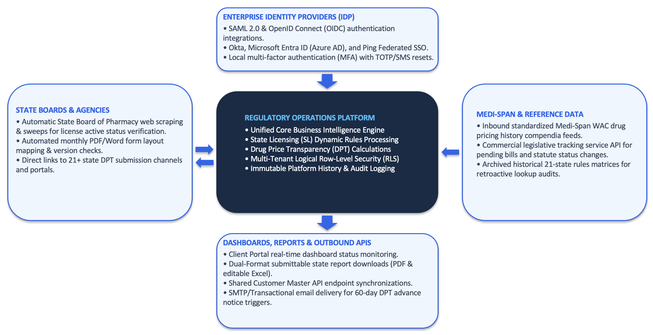
Data Model Approach
The solution adopts a shared business data model that establishes a single source of truth across State Licensing, Drug Price Transparency, and Regulatory Intelligence capabilities.
Common business entities are maintained centrally and reused across modules to eliminate duplication, improve reporting consistency, and simplify future expansion.
Logical Data Domains
Data Domain | Representative Entities
Organisation & Access | Organisation, User, Contact, Subscription, Role
State Licensing | Project, License, Application, Renewal, Deficiency
Drug Price Transparency | Product, NDC, Pricing History, Pricing Event, Report
Shared Services | Document, Regulatory Content, Rule, Audit Record
The architecture supports effective-dated entities, enabling regulatory rules, thresholds, forms, and reference data to evolve over time while preserving historical compliance outcomes and auditability.

Conceptual Data Model

Organisation
│
├── Users
│
├── State Licensing Projects
│ │
│ ├── Licenses
│ ├── Applications
│ └── Documents
│
└── DPT Products
│
├── NDCs
├── Pricing History
└── Reports

Data Loading and Migration Approach
The migration strategy is designed to preserve historical records, minimize operational disruption, and provide confidence in data quality before production deployment.
Migration activities will be executed through a structured and repeatable process with formal validation at each stage.
Migration Methodology

Phase 1 – Discovery and Assessment
Current-state applications, spreadsheets, document repositories, reporting datasets, and reference data sources will be assessed to determine:
- Data volumes
- Data quality
- Business ownership
- Retention requirements
- Migration complexity

Phase 2 – Mapping and Transformation
Source-to-target mappings will be defined for all in-scope entities. Validation and reconciliation rules will be established to ensure completeness and accuracy during migration.

Phase 3 – Trial Migration and Validation
One or more trial migrations will be executed to validate:
- Record counts
- Data quality
- Referential integrity
- Historical traceability
- Business usability
Results will be reviewed jointly with Two Labs stakeholders.

Phase 4 – Production Migration
Production migration will be executed during a controlled cutover window with:
- Final data reconciliation
- Business validation
- User acceptance
- Hypercare support
Assumptions
Area | Assumption
Existing Applications | Read access to existing State Licensing and DPT applications will be provided.
Historical Data | Required historical licensing, pricing, reporting, and compliance data will be available in extractable formats.
Documentation | Existing process, interface, and data documentation will be provided where available.
SME Participation | Business SMEs will participate in rule validation, data reconciliation, and acceptance activities.
Data Quality | Any significant source-data quality issues identified during discovery will be jointly assessed and remediated.
Integration Access | Access to APIs, extracts, interface specifications, and third-party providers will be made available where integration is required.

Benefits of the Proposed Approach
The proposed integration and data architecture provides:
- A scalable API-first integration model.
- A single source of truth across State Licensing and Drug Price Transparency.
- Preservation of historical compliance and reporting data.
- Reduced migration risk through staged validation and reconciliation.
- Support for future regulatory services and SaaS expansion without significant architectural change.
- Improved reporting, auditability, and operational transparency.
This approach balances implementation speed, operational simplicity, regulatory traceability, and long-term maintainability while providing a robust foundation for Two Labs' future growth strategy.

Trade-offs and proportionality
Explain the significant trade-offs and where you have deliberately avoided complexity. If you propose AI-enabled capabilities, explain why, and address accuracy, human oversight, evaluation, security, accountability and running cost.
The proposed architecture has been designed to balance the three primary objectives identified in the RFP:
- Development Efficiency: Accelerate delivery through reuse, standardization, and configuration-driven capabilities.
- Cost to Serve: Minimize recurring infrastructure, licensing, and operational costs.
- Operational Simplicity: Reduce administrative overhead and dependency on specialist resources.
Where architectural alternatives introduced complexity without delivering proportional business value, they were deliberately excluded.

Architectural Trade-Off Analysis
Architectural Decision | Alternative Considered | Rationale | Business Benefit
Modular domain-based platform architecture | Distributed microservices architecture | Projected transaction volumes and functional scope do not justify the additional complexity associated with service orchestration, distributed transactions, and platform operations. | Reduced implementation complexity, lower support effort, and lower infrastructure costs.
Shared multi-tenant platform with logical tenant isolation | Dedicated database per customer | Dedicated databases significantly increase infrastructure footprint, operational effort, and migration complexity without providing proportional business value for the expected client volumes. | Lower cost-to-serve while maintaining secure client data segregation.
Configurable rules framework | Hard-coded regulatory logic | Regulatory requirements change frequently and must be maintainable by regulatory SMEs without software releases. | Faster regulatory change adoption and reduced dependency on development teams.
Unified compliance platform | Continued operation of multiple applications, spreadsheets, and task-tracking tools | Maintaining multiple systems perpetuates duplicate processes, fragmented data, and higher operational costs. | Single source of truth, simplified operations, and improved maintainability.
Lightweight event and workflow orchestration | Enterprise-scale event streaming platforms | Anticipated transaction volumes do not require the complexity and operational overhead of large-scale streaming architectures. | Lower operational overhead and simplified platform administration.

Complexity Deliberately Avoided
The proposed solution intentionally excludes several architectural patterns that would increase implementation complexity, operating costs, or support effort without materially improving business outcomes.

Multi-Region Active-Active Databases
The solution adopts a highly available, multi-zone deployment model rather than a multi-region active-active database architecture.
A multi-region write architecture introduces additional complexity associated with data synchronization, conflict resolution, operational monitoring, and disaster recovery. Based on the expected transaction volumes and domestic US operating model, a highly available regional deployment provides the required resilience while maintaining operational simplicity.

Enterprise Integration Bus (ESB)
The solution adopts an API-first integration model rather than introducing a centralized enterprise integration bus.
The anticipated integration landscape is effectively addressed through modern REST-based services and event-driven workflows without introducing additional middleware administration and licensing overhead.

Proprietary Low-Code Platforms
The solution avoids dependency on proprietary low-code platforms.
While low-code solutions may accelerate initial development, they often introduce long-term licensing costs, platform lock-in, reduced flexibility for complex regulatory logic, and constraints around specialized document generation and calculation capabilities. The proposed architecture preserves flexibility while supporting long-term ownership and maintainability.

AI and Automation Strategy
The proposed solution does not rely on AI technologies to satisfy any Required capability within the RFP scope.
All core compliance functions, including:
- Licensing determination
- Regulatory rule evaluation
- Pricing calculations
- Trigger identification
- Due-date calculations
- Report generation
are implemented using deterministic and fully auditable business logic.
This approach ensures regulatory transparency, repeatability, and compliance defensibility.

Optional AI-Enabled Capabilities
Where selected by Two Labs, AI may be applied in support of specific optional capabilities, including:
Optional Capability | Proposed AI Application
OPT-07 | Assisted document classification, extraction, and intake review
OPT-16 | Assisted regulatory monitoring and draft content generation

Human Oversight
All AI-assisted outputs remain subject to human review and approval prior to operational use.
AI-Assisted Output
│
▼
SME / Analyst Review
│
▼
Approval
│
▼
Publication or Operational Use
No AI-generated regulatory interpretation, compliance determination, or reporting obligation is automatically published or executed.

Governance and Accountability
Any AI-enabled capability will operate within a governed framework incorporating:
- Human-in-the-loop review
- Confidence-based processing thresholds
- Audit logging and traceability
- Performance monitoring
- Controlled release processes
- Data security and privacy controls
AI is therefore positioned as an operational productivity tool rather than a compliance decision-making mechanism.

Economic and Operational Benefits
The proposed architecture prioritizes maintainability, configurability, and operational efficiency over unnecessary technical complexity.
Key benefits include:
- Reduced implementation and operating costs through reuse and standardization.
- Regulatory agility through business-managed rules and reference data.
- Lower ongoing support effort through simplified operational architecture.
- Reduced vendor dependency through configurable business capabilities.
- Clear auditability and traceability across all compliance activities.
- A pragmatic foundation for future self-service, automation, and SaaS commercialization initiatives.

Delivery methodology and implementation plan <Kundan/Vikrant/Hari/Praveen>

Methodology
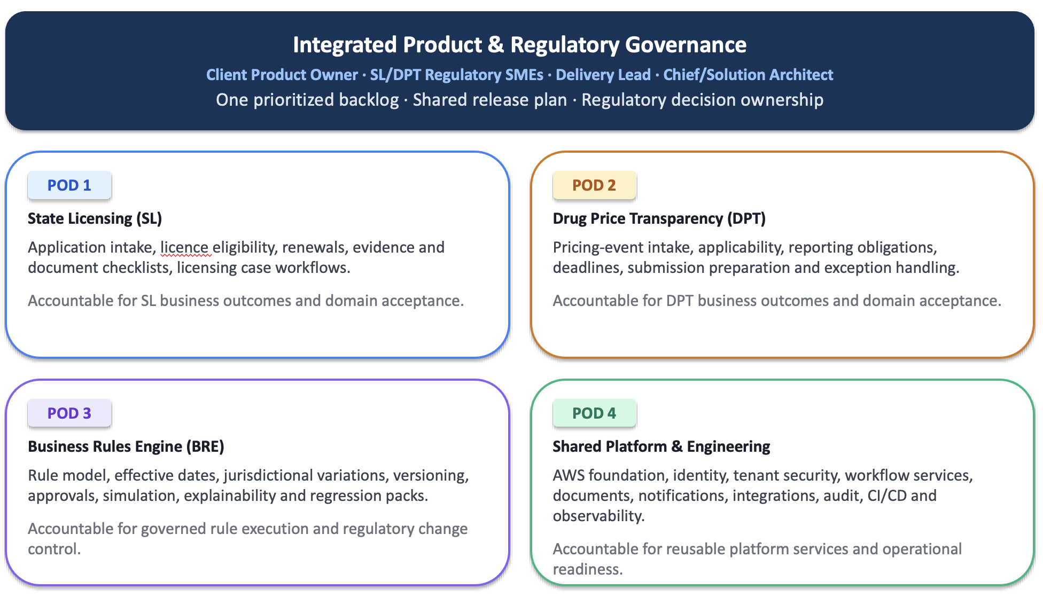

Phases and milestones
Phase | Capabilities delivered (requirement IDs or capability areas) | Duration | Milestone and acceptance point

Schedule
Provide a schedule and identify the critical path.

Dependencies and client participation
Two Labs / EPG role | Activities | Estimated effort | When

Testing and quality assurance
We propose a risk-based quality assurance approach covering the State Licensing and Drug Price Transparency (DPT) modules. Testing will prioritise regulatory accuracy, timely identification of obligations, protection of sensitive information and reliable end-to-end workflows. Acceptance criteria, testing responsibilities and measurable quality targets will be agreed with Two Labs before development begins.

Hexaware will leverage the existing QA tool set in EPGs environment or suggest alternate tools which will be leveraged for testing across functional and non-functional testing services as below :
Testing Service | Tool | AI Assistant to be leveraged
UI / API testing | Playwright | GitHub copilot
Performance testing | Jmeter | GitHub copilot
Security Testing | To be updated
Accessiblity Testing | To be updated

Test planning and traceability
During discovery, we will establish a test strategy defining scope, environments, test data, responsibilities, entry and exit criteria, and required evidence. A requirements traceability matrix will link each Required requirement to its agreed acceptance criteria, test cases, execution results and defects. Optional capabilities will be tested where included in the agreed delivery scope.

Functional and end-to-end testing
Testing will cover licensing determination, intake, document handling, application generation, licence tracking and automatic renewal creation. DPT coverage will include product and pricing data, reporting triggers, scenario modelling, historical lookbacks, report generation, submission tracking and manual overrides. Positive, negative and boundary tests will validate business rules, workflow transitions, exception handling and audit records.

Rule regression testing
A dedicated rule regression suite will verify that regulatory rule changes and software releases produce the expected outcomes without introducing unintended changes elsewhere. In collaboration with Two Labs subject-matter experts, we will establish a version-controlled baseline of licensing profiles and historical pricing events, with independently approved expected results.

The suite will cover:

State Licensing rules: Licence, application form and supporting-document determination across agreed combinations of state, business activity, facility and distribution model.
DPT calculations and triggers: Launch and price-increase thresholds, branded and generic distinctions, look-back periods, calculation precision, triggered reports and due dates.
Boundary conditions: Values below, at and above thresholds; events around rule effective dates; and relevant calendar boundaries.
Historical consistency: Correct application of the rule version effective for each event, ensuring new rules, amendments and repeals do not unintentionally change earlier results.
Modelling and overrides: Consistency between modelled and actual pricing events, correct recalculation after overrides, and preservation of original results and audit history.
The agreed suite will be rerun on every rule change and every software release. Each run will compare actual and approved expected results and provide evidence of the rule versions, scenarios executed, discrepancies and resolution status. Intended regulatory changes will require SME approval of revised expected results; baselines will not be changed solely to match system output. Release acceptance will require no discrepancies against the agreed regression set.
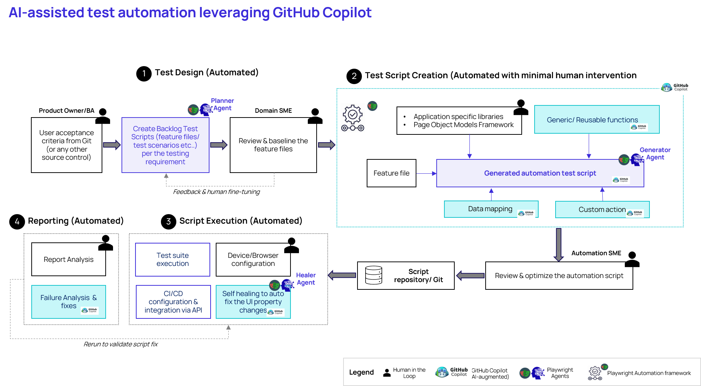

Integration Testing
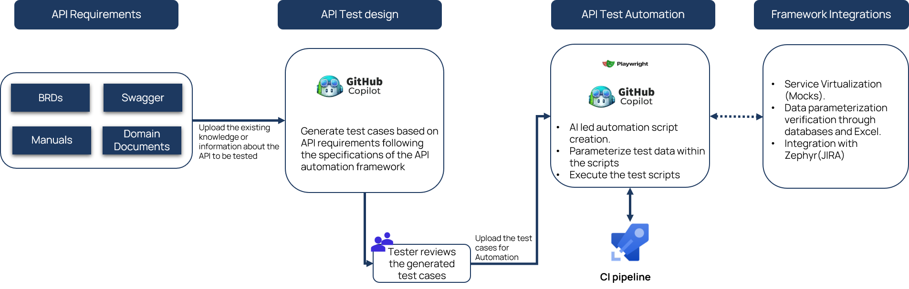
Integration testing will cover agreed data loads, compendia file imports, notifications and external interfaces, including invalid inputs, partial failures and retries. Generated applications and reports will be validated against agreed state-specific templates and reference outputs.

Security and penetration testing
Testing will verify authentication, role-based access, client data isolation and subscription entitlements. Particular attention will be given to sensitive personal information, state-system credentials and confidential pricing data, including their protection in logs, exports and non-production environments. Independent penetration testing will be completed before client-facing go-live, with findings remediated and retested against agreed release criteria.
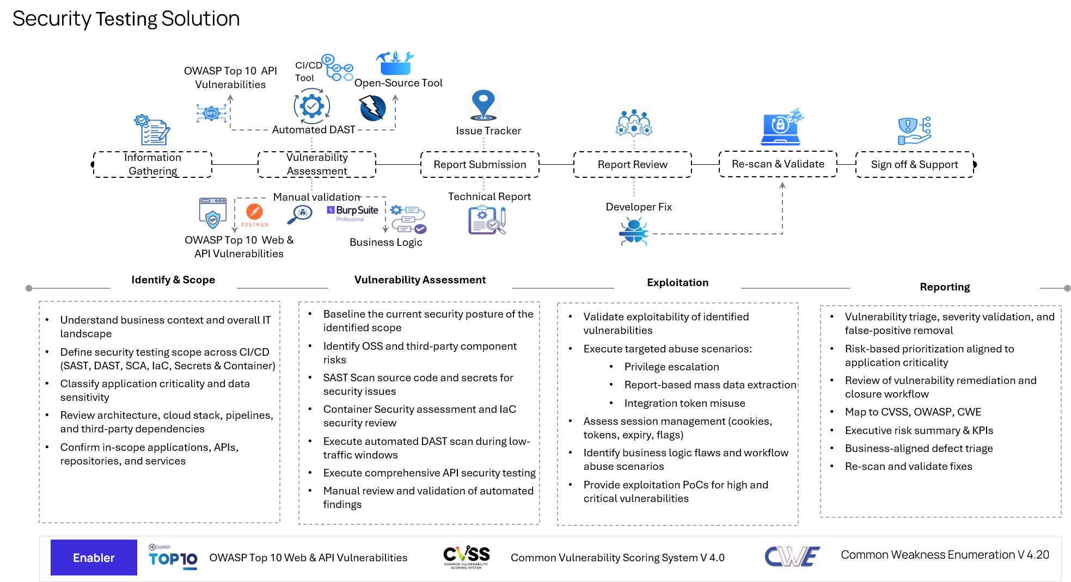

Performance and operational readiness
Performance testing will use representative workloads and data volumes, with concurrency, response-time, batch-processing and growth targets agreed during discovery. Operational-readiness checks will verify monitoring, failure handling, backup restoration and recovery against agreed objectives. Documentation, knowledge transfer and support handover will be completed before go-live.

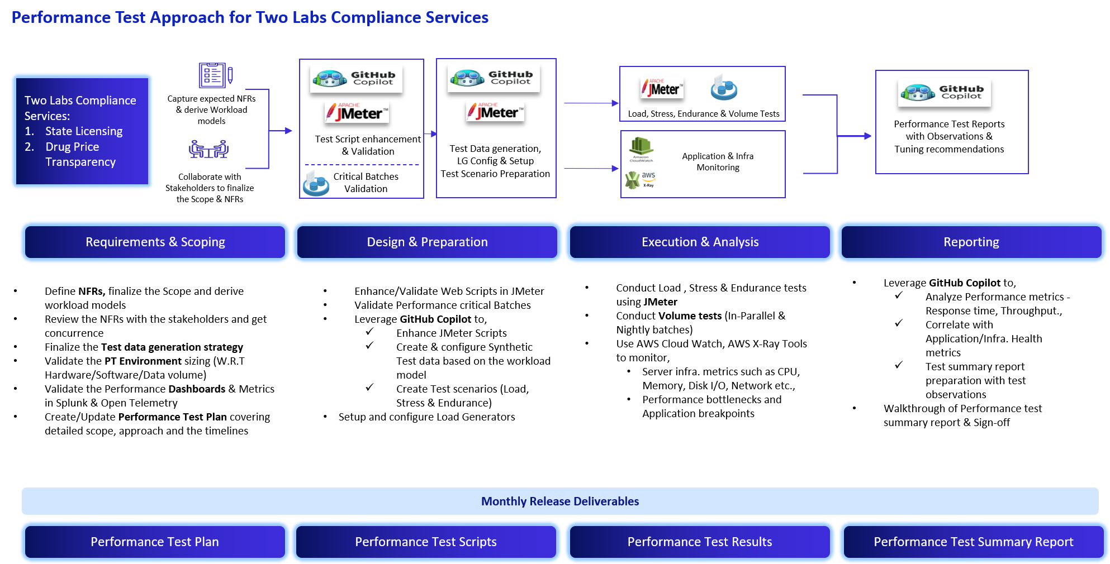

Accessibility Testing
Accessibility testing will assess whether the State Licensing and DPT modules can be used effectively by people with disabilities, with the target standard and conformance level proposed as WCAG 2.2 Level AA—agreed during discovery. Testing will combine automated checks with manual keyboard-only and screen-reader testing across agreed browsers and assistive technologies. Coverage will include navigation, focus order and visibility, colour contrast, zoom and reflow, form labels, validation errors, status notifications and accessible tables. Particular attention will be given to critical workflows such as intake completion, document uploads, application review and reporting, with generated documents assessed where included in the agreed scope. Findings will be recorded, prioritised by user impact, remediated and retested, with accessibility evidence included in the release test summary.

Test environments and automation
Testing will use controlled non-production environments and anonymised or synthetic data provisioned by Two labs. Automation will prioritise rule regression, regulatory calculations, critical workflows and integration checks. Automated tests will be integrated into the delivery pipeline, supported by manual exploratory testing for complex scenarios and exceptions.

Defect management and user acceptance testing
Defects will be recorded with severity, business impact, reproduction steps and supporting evidence. Fixes will undergo retesting and relevant regression testing. Two Labs will perform UAT with vendor support for test preparation, execution, defect triage and evidence collection. Release-blocking criteria and sign-off responsibilities will be agreed in advance.

QA deliverables and acceptance
Deliverables will include the test strategy, requirements traceability matrix, test cases, automated rule regression suite, execution evidence, defect reports, security and performance results,. Each release will include a test summary identifying coverage, results, outstanding defects and residual risks. Final acceptance will be based on the agreed requirements, acceptance criteria and authorised sign-off.

Implementation, training and transition

Proposed project team <Kundan, Santhosh, Hari,Praveen>
Role | Name (if known) | Location | Allocation | Relevant experience

State which roles are provided by subcontractors and how continuity of key personnel will be assured.

Security and non-functional compliance<Hari/Kundan/ Infra security team spoc,??>
For each documented non-functional requirement (NFR-nnn) and each confirmation category (NFR-C-nnn), summarise how the solution complies and how compliance will be demonstrated. For each NFR-C category, state the level your base price assumes and the cost of the next level.

ID | Level assumed in base price | How demonstrated | Cost and operating impact of higher levels

Operating model and support approach <Santhosh/Kundan/Vikrant>

Steady-state operating activities
Activity | Frequency | Performed by (vendor / Two Labs / EPG / third party) | Skills required | Estimated effort per month

Support model
Describe support tiers, hours, response and resolution commitments, and the price of each option.

Maintenance, upgrades and releases

Business continuity

Exit and transition

Cost-efficiency and total-cost-of-ownership analysis < Kundan /Saurabh>
Answer each item in RFP Section 9 with evidence. At minimum:
list the major cost drivers, one-time and recurring, and how your design minimises each;
explain how recurring costs scale with clients, users, NDCs, facilities and projects, and where step changes occur;
explain the trade-offs between development efficiency, cost to serve and operational overhead in your design;
identify activities that need specialist resources and how you limit that dependency.

Commercial proposal <Saurabh/Anthony>
Summarise the commercial schedules in the workbook and state:
the commercial model (for example fixed price by phase or capped time and materials);
payment milestones;
how change requests will be priced;
the rate card for additional work;
prices for each optional capability and optional service.

Assumptions, dependencies and exclusions<<Kundan, Santhosh, Hari,Praveen>

# | Type (assumption / dependency / exclusion) | Description | Related requirement or clarification item | Effect if not valid

Include your stated assumption for every clarification item CLR-01 to CLR-11.

Relevant experience and references <Manick>
Client (or description if confidential) | Engagement summary | Relevance to this RFP | Year | Reference contact
IQVIA |  |  |  | Manick

Include evidence that delivered solutions have been maintained economically (for example running-cost or support-effort data).

Risks and proposed mitigations <Kundan, Santhosh, Hari,Praveen>

# | Risk | Likelihood | Impact | Mitigation | Owner

Questions requiring clarification<Kundan, Santhosh, Hari,Praveen>

# | Question | Related section or requirement | Effect on proposal

Declaration <Saurabh/Anthony>
I confirm that this proposal is accurate, that capabilities described as Committed are included in the price and plan, and that the proposal remains valid for the stated period.
Name | Role | Signature | Date

About Hexaware

Hexaware is a global technology and business process services company. Our 33,000+ Hexawarians wake up every day with a singular purpose; to create smiles through great people and technology. With this purpose gaining momentum, we are well on our way to realizing our vision of being the most loved digital transformation partner in the world. We also seek to protect the planet and build a better tomorrow for our customers, employees, partners, investors, and the communities in which we operate.

With 68 offices in 19 countries, we empower enterprises worldwide to realize digital transformation at scale and speed by partnering with them to build, transform, run, and optimize their technology and business processes.

Learn more about Hexaware at www.hexaware.com
www.Hexaware.com
© 2026 Hexaware Technologies Limited. All rights reserved

